Appendix B: Audience Persona Characterization Tool
This tool helps to identify target audiences and characterize their personas to assist in the development of messages before and during an escalating public health issue.¹ However, care should be taken to avoid stereotyping people while using the tool. Use the template below to organize what you know about your audience and create a fictional audience persona.
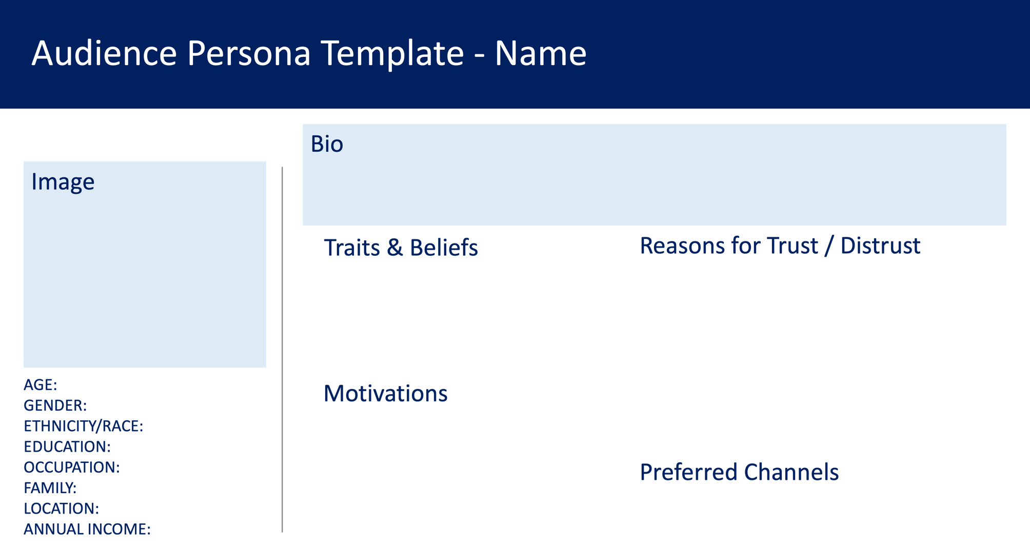

Category | Your answers
Purpose | Prebunk misleading information related to individual risk & help audience anticipate public health messages
Message Goals | Increase people’s ability to detect false information
Persona & Trust Characterization | High Trust Person  Add characteristics (eg, racial identity, location) | Low Trust & Adversarial Mindset  Add characteristics (eg, racial identity, location) | Low Trust & Historically Underreached  Add characteristics (eg, racial identity, location)
Traits & Beliefs | Trusts authority, expertise, and science | Believes government actions overreach and interfere in individuals' autonomy | Feels their community has been left behind by the government
Motivations | Promoting a healthy community​ | Sense of control​ | Care for and protect self, community, and loved ones​
Reasons for Trust/Distrust | Positive experiences with medical and government establishments | Lack of transparency in government and public health officials’ actions and decision-making | Poor treatment outcomes of people in the community​
Preferred Channels | Social media for public health updates​ | Face-to-face conversations​ at local community events & religious gatherings | Local newspaper​, face-to-face conversations at local community events & religious gatherings
Rhetoric | Highlighting the scientific process | Individual choice and personal responsibility | Shared responsibility
Justification  and Citation | Refer to official entities such as CDC, WHO, state public health departments | Refer to official entities in addition to trusted local messengers from shared community | Offer in-person or on-the-phone Q&A sessions from trusted local messengers
You can fill out the table below to organize information gathered using audience personas, especially in collaboration with community stakeholders. The included text serves only as examples of ways that the table could be filled out; you can delete the text under “Your answers” and fill in the table with your own information.

References
1. Potter C, Fink ER, Nagar A, et al. Summary Report for Task 12: Identify Messaging Components to Manage Expected Health-Related Misinformation and Disinformation That Reduces Trust in Public Health. Johns Hopkins Center for Health Security, CDC; 2023.

